1. Generation of number series 1, 2, 3, 4,…..n

Program :

#include<stdio.h>

#include<conio.h>

int main()

{

int N, i;

printf("Enter the value of N (limit): ");

scanf("%d", &N);

printf("\n");

for(i=1; i<=N; i++)

{

if(i==N)

printf("%d", i);

else

printf("%d,", i);

}

getch();

return 0;

}

OUTPUT:

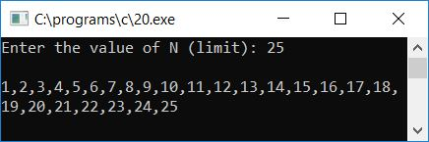

1. Generation of even number series 2, 4, 6, …..n

PROGRAM:

#include <stdio.h>

int main()

{

int i, n;

printf("Print all even numbers till: ");

scanf("%d", &n);

printf("Even numbers from 1 to %d are: \n", n)

for(i=1; i<=n; i++)

{

/* Check even condition before printing */

if(i%2 == 0)

{

printf("%d\n", i);

}

}

return 0;

}

OUTPUT :

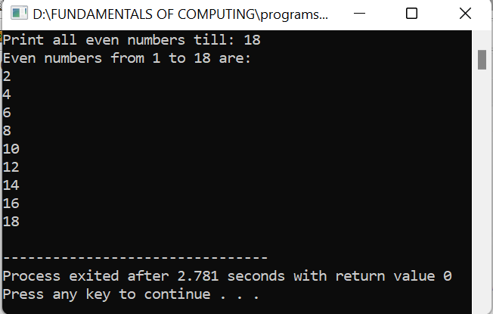

1. Generation of ODD number series 1, 3, 5, …..n

PROGRAM :

#include <stdio.h>

int main()

{

int i, n;

printf("Print odd numbers till: ");

scanf("%d", &n);

printf("All odd numbers from 1 to %d are: \n", n);

for(i=1; i<=n; i++)

{

/* If 'i' is odd then print it */

if(i%2!=0)

{

printf("%d\n", i);

}

}

return 0;

}

OUTPUT :

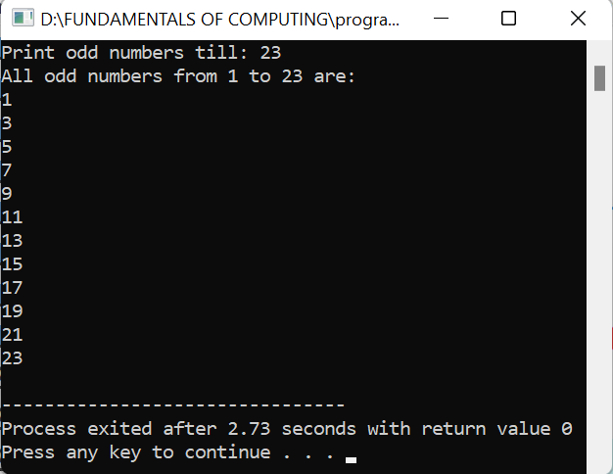

1. Generation of Fibonacci series 0, 1, 1, 2, 3, 5, 8, …..n

PROGRAM :

#include <stdio.h>

int main() {

int i, n;

int t1 = 0, t2 = 1;

int nextTerm = t1 + t2;

printf("Enter the number of terms: ");

scanf("%d", &n);

printf("Fibonacci Series: %d, %d, ", t1, t2);

for (i = 3; i <= n; ++i) {

printf("%d, ", nextTerm);

t1 = t2;

t2 = nextTerm;

nextTerm = t1 + t2;

}

return 0;

}

OUTPUT :

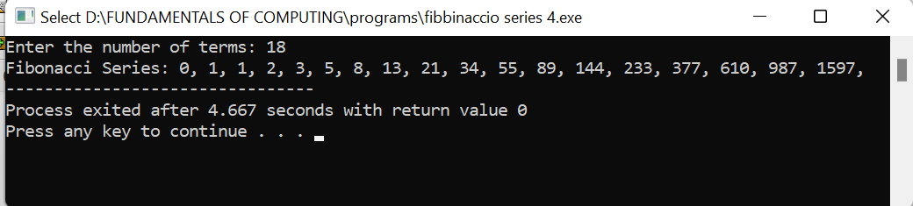

1. Summing up series 1 + 2 + 3 + 4….. +n

PROGRAM :

#include <stdio.h>

int series_sum(int n)

{

if (n % 2 == 0)

return (-(n / 2));

else

return ((n + 1) / 2);

}

int main()

{

int n;

printf("Series:1-2+3-4+5-6+7-8.....N\n");

printf("Want some up to N terms?\nEnter the N term:");

scanf("%d", &n);

printf("Sum is:%d", series_sum(n));

return 0;

}

OUTPUT :

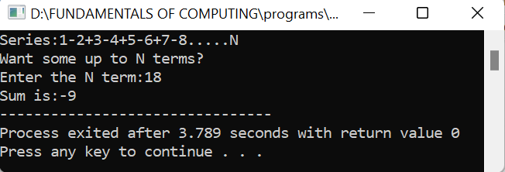

1. Summing up Even Number series

PROGRAM :

#include <stdio.h>

int main()

{

int i, n, sum=0;

printf("Enter upper limit: ");

scanf("%d", &n);

for(i=2; i<=n; i+=2)

{

sum += i;

}

printf("Sum of all even number between 1 to %d = %d", n, sum);

return 0;

}

OUTPUT :

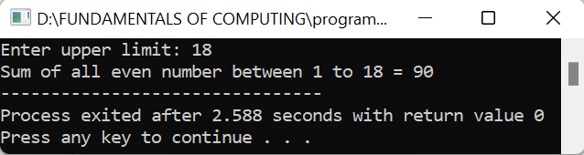

1. Summing up cubes of n numbers

PROGRAM:

#include<stdio.h>

int main()

{

int n,sum;

printf("enter the value of n:");

scanf("%d",&n);

sum=(n*n)*((n+1)*(n+1))/4;

printf("sum of square of %d natural numbers=%d",n,sum);

}

OUTPUT :

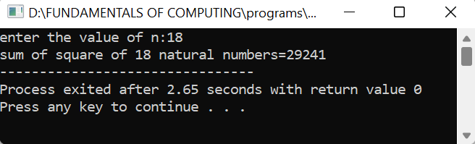

1. Finding whether the given integer is odd or even

PROGRAM :

#include <stdio.h>

int main() {

int num;

printf("Enter an integer: ");

scanf("%d", &num);

if(num % 2 == 0)

printf("%d is even.", num);

else

printf("%d is odd.", num);

return 0;

}

OUTPUT :

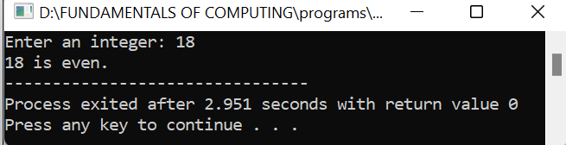

1. Product series (Factorial of a given number)

PROGRAM :

#include <stdio.h>

unsigned int factorial(unsigned int n)

{

if (n == 0)

return 1;

return n * factorial(n - 1);

}

int main()

{

int num = 5;

printf("Factorial of %d is %d", num, factorial(num));

return 0;

}

OUTPUT :

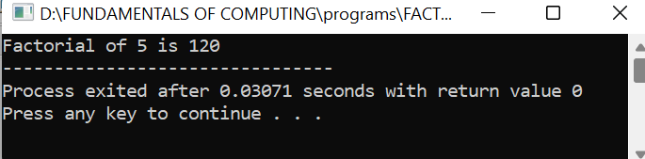

10)Finding given number is Armstrong or NOT

PROGRAM :

#include <stdio.h>

int main() {

int num, originalNum, remainder, result = 0;

printf("Enter a three-digit integer: ");

scanf("%d", &num);

originalNum = num;

while (originalNum != 0) {

remainder = originalNum % 10;

result += remainder * remainder * remainder;

originalNum /= 10;

}

if (result == num)

printf("%d is an Armstrong number.", num);

else

printf("%d is not an Armstrong number.", num);

return 0;

}

OUTPUT:

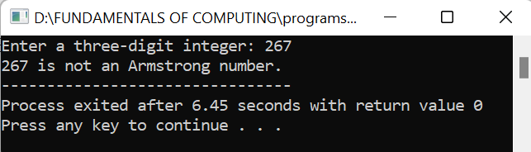

11)Summing up any n numbers and finding average

PROGRAM :

#include<stdio.h>

int main()

{

int i,n,Sum=0,numbers;

float Average;

printf("\nPlease Enter How many Number you want?\n");

scanf("%d",&n);

printf("\nPlease Enter the elements one by one\n");

for(i=0;i<n;++i)

{

scanf("%d",&numbers);

Sum = Sum +numbers;

}

Average = Sum/n;

printf("\nSum of the %d Numbers = %d",n, Sum);

printf("\nAverage of the %d Numbers = %.2f",n, Average);

return 0;

}

OUTPUT:

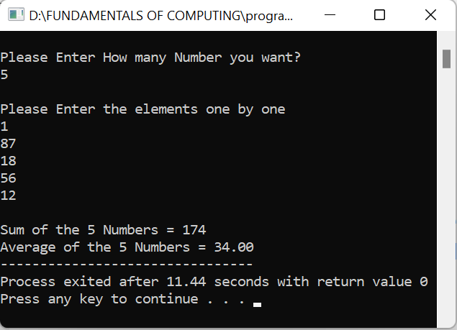

12)Printing digits of an integer number

PROGRAM:

#include <stdio.h>

int main() {

int number;

printf("Enter an integer: ");

// reads and stores input

scanf("%d", &number);

// displays output

printf("You entered: %d", number);

return 0;

}

OUTPUT :

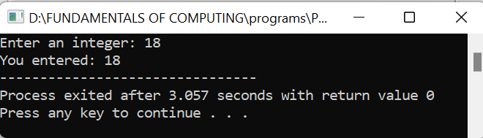

12)Summing up the digits of an integer number

PROGRAM :

#include<stdio.h>

int main()

{

int n,sum=0,m;

printf("Enter a number:");

scanf("%d",&n);

while(n>0)

{

m=n%10;

sum=sum+m;

n=n/10;

}

printf("Sum is=%d",sum);

return 0;

}

OUTPUT :

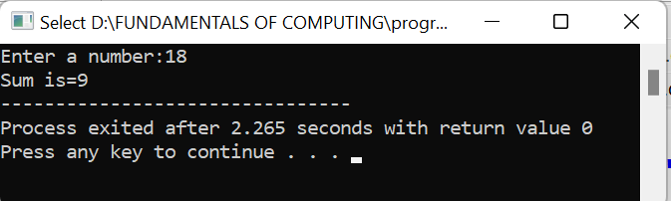

13)Reversing the digits of an integer number

PROGRAM :

#include <stdio.h>

int main() {

int n, reverse = 0, remainder;

printf("Enter an integer: ");

scanf("%d", &n);

while (n != 0) {

remainder = n % 10;

reverse = reverse * 10 + remainder;

n /= 10;

}

printf("Reversed number = %d", reverse);

return 0;

}

OUTPUT:

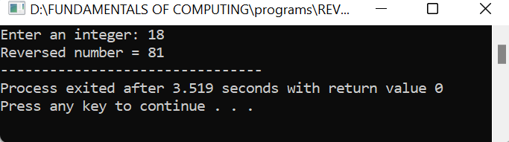

15)Finding the given integer is positive or negative

PROGRAM:

#include <stdio.h>

int main() {

double num;

printf("Enter a number: ");

scanf("%lf", &num);

if (num <= 0.0) {

if (num == 0.0)

printf("You entered 0.");

else

printf("You entered a negative number.");

}

else

printf("You entered a positive number.");

return 0;

}

OUTPUT:

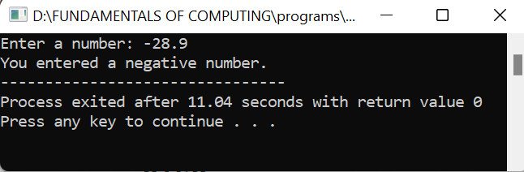

16)Swapping two numbers with a temporary variable

PROGRAM:

#include<stdio.h>

int main() {

double first, second, temp;

printf("Enter first number: ");

scanf("%lf", &first);

printf("Enter second number: ");

scanf("%lf", &second);

temp = first;

first = second;

second = temp;

printf("\nAfter swapping, first number = %.2lf\n", first);

printf("After swapping, second number = %.2lf", second);

return 0;

}

OUTPUT:

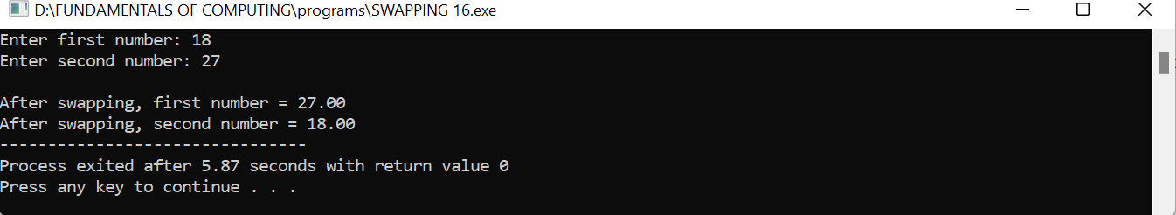

17)Program to convert decimal to hexadecimal

PROGRAM:

#include <stdio.h>

int main()

{

long decimalnum, quotient, remainder;

int i, j = 0;

char hexadecimalnum[100];

printf("Enter decimal number: ");

scanf("%ld", &decimalnum);

quotient = decimalnum;

while (quotient != 0)

{

remainder = quotient % 16;

if (remainder < 10)

hexadecimalnum[j++] = 48 + remainder;

else

hexadecimalnum[j++] = 55 + remainder;

quotient = quotient / 16;

}

for (i = j; i >= 0; i--)

printf("%c", hexadecimalnum[i]);

return 0;

}

OUTPUT:

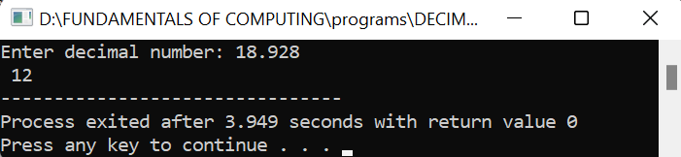

18)Program to convet Hexa to decimal

PROGRAM:

#include <stdio.h>

#include <math.h>

#include <string.h>

#define ARRAY_SIZE 20

int main()

{

char hex[ARRAY_SIZE];

long long decimal = 0, base = 1;

int i = 0, value, length;

/* Get hexadecimal value from user */

printf("Enter hexadecimal number: ");

fflush(stdin);

fgets(hex,ARRAY_SIZE,stdin);

length = strlen(hex);

for(i = length--; i >= 0; i--)

{

if(hex[i] >= '0' && hex[i] <= '9')

{

decimal += (hex[i] - 48) * base;

base *= 16;

}

else if(hex[i] >= 'A' && hex[i] <= 'F')

{

decimal += (hex[i] - 55) * base;

base *= 16;

}

else if(hex[i] >= 'a' && hex[i] <= 'f')

{

decimal += (hex[i] - 87) * base;

base *= 16;

}

}

printf("\nHexadecimal number = %s", hex);

printf("Decimal number = %lld\n", decimal);

return 0;

}

OUTPUT:

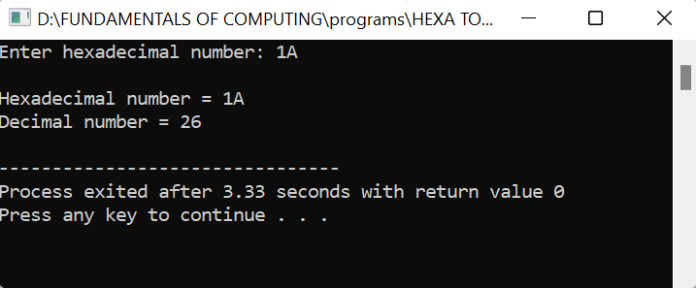

1. Program to convert decimal to octal